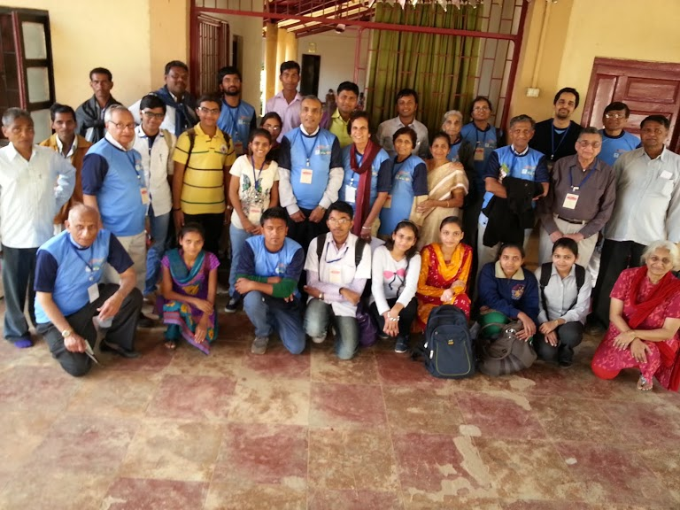 | Medical YATRA-2016  Jan.23-30
You are WELCOME to Join &
Experience the unlimited joy & blessings!
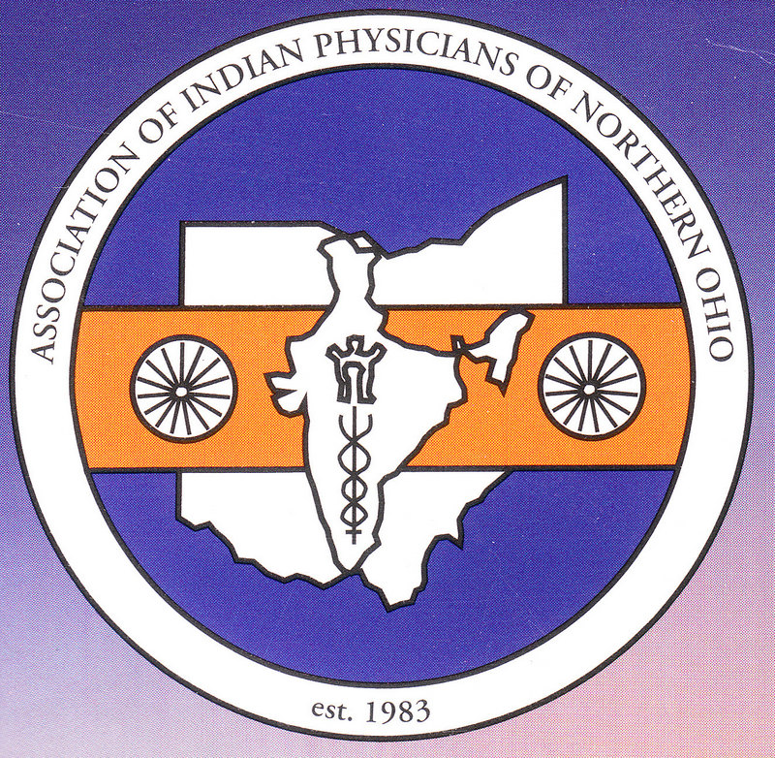 | Association of Indian Physicians  of Northern Ohio  (websites: aipno.org/medicalyatra,clevelandpeople.com)
In cooperation with
ARCH | Action Research in Community Health  Nagaria, Guj.

“The best way to find yourself is to lose yourself in the service of others.” -Mahatma Gandhi
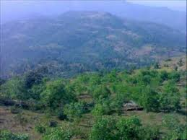 | 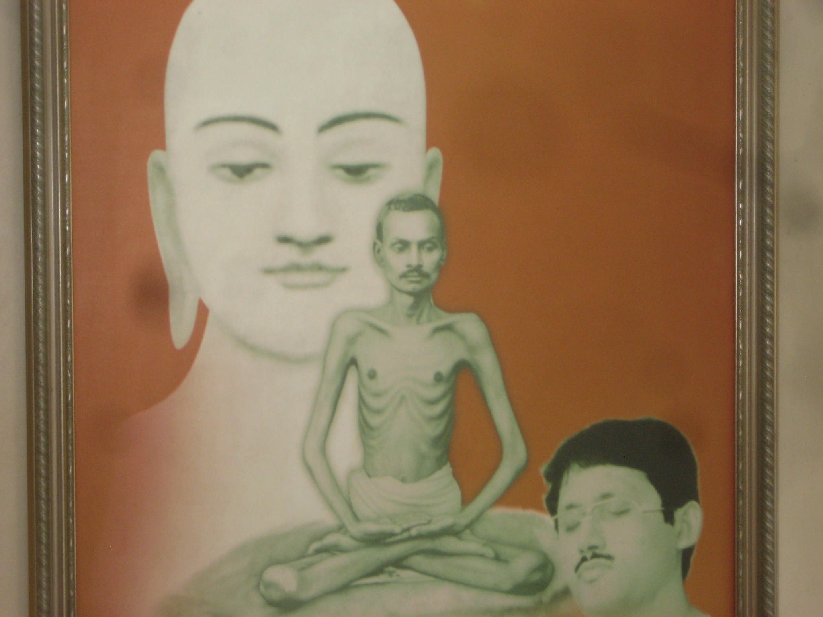 | 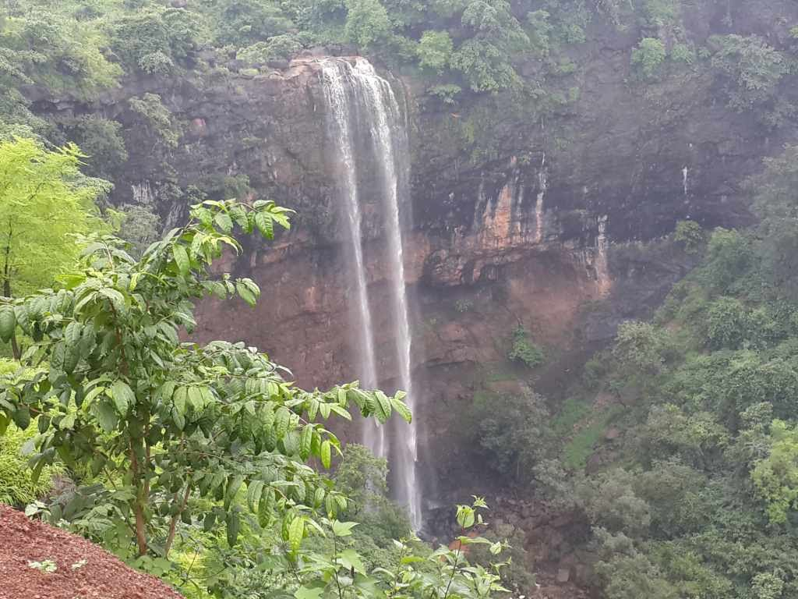
Primary Health–Medical & Dental-Eye Camp
(Educate, Prevent diseases, Save the Lives!)

REGISTRATION FEE: $375. INCLUDEs Lodging/Boarding and Local Travel
(Other Attractions: Wilson Hills, Water falls, Temple visits, Shopping etc…extra at COST)

Jaya Shah 440-460-1037 Gita Gidwani 571-830-4333
Murthy Vuppala 440-617-6660 Saroj Mahalaha 440-930-9006
Ramesh Shah 440-460-1037 Arvind Shah 609-443-1814
(rameshcleveland@gmail.com)

